TUM Department of Computer Science I6 SS 2019

**Exam Autonomes Fahren (IN2356) – SS 2019**

**02.08.2019**

# **Part 1: Sensors**

**1.1** **What is the Radar Cross Section property of an object and how can you express it in terms of signal energy?**

*Answer:*

*Radar cross-section (RCS) is a measure of how detectable an object is by radar. Therefore, it is called electromagnetic signature of the object. A larger RCS indicates that an object is more easily detected. An object reflects a limited amount of radar energy back to the source.*

*The ability of a radar receiver to detect a weak echo signal is limited by the noise energy that occupies the same portion of the frequency spectrum as does the signal energy. The weakest signal the receiver can detect is called the minimum detectable signal.*

*An object reflects a limited amount of radar energy back to the source. The factors that influence this include:*[*[1]*](https://en.wikipedia.org/wiki/Radar_cross-section#cite_note-ReferenceA-1)

*· the material of which the target is made;*

*· the size of the target relative to the* [*wavelength*](https://en.wikipedia.org/wiki/Wavelength) *of the illuminating radar signal;*

*· the absolute size of the target;*

*· the* [*incident angle*](https://en.wikipedia.org/wiki/Angle_of_incidence_(optics)) *(angle at which the radar beam hits a particular portion of the target, which depends upon the shape of the target and its orientation to the radar source);*

*· the reflected angle (angle at which the reflected beam leaves the part of the target hit; it depends upon incident angle);*

*· the polarization of the transmitted and the received radiation with respect to the orientation of the target*

**1.2** **List two active and one passive sensor, which are used within the**

**context of autonomous driving and explain why they are considered active or passive.**

/3

**1.3** **Explain the physical effects refraction and reflection and their relation to entrance and exit angles.**

/2

**1.4** **For model categories and properties of BRDF, provide the names or properties of the models missing in the figure. (You can write the text next to the empty boxes and associate box and your proposed solution with an arrow between the empty box and your text.)**

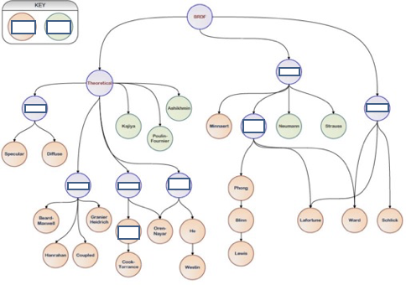

/5

**1.5** **The following equation indicates the reflection of Lidar Pulses reflected at plain surfaces of solid objects. Describe the variables below and explain the equation, including the difference for the two cases.**



**Explain the corresponding variables:**

𝐴𝑇𝐴:

𝐴𝑇:

𝛽0:

## Explanation:

*First equation: target area is greater than or equal to cross-section area.*

*We have a plain surface of the solid object, it does not change the time signature of the laser part.*

*If you send out a signal with a certain shape, you would recieve the signal with the same shape.*

*Second equation: target area is lesser than cross-section area*

*Depending on how you hit the target, part of your signal hits the deck and part hits the later end so the shape may change.*

/4

# **Part 2: Path Planning**

**2.1** **Explain the differences between path, motion and trajectory.**

/3

**2.2** **Why is it useful to define constraints for a motion system and what are the differences between holonomic and nonholonomic constraints?**

/3

**2.3** **Explain the use of artificial potential fields for motion planning? How can a robot get stuck using this method before reaching the goal? Support your argumentation by drawing resulting gradients of an exemplary potential field into it, which could lead to the robot getting stuck.**

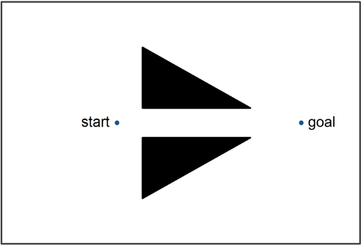

/3

**2.4** **Sketch the corresponding acceleration and yaw profiles for the velocity diagram on the left.**

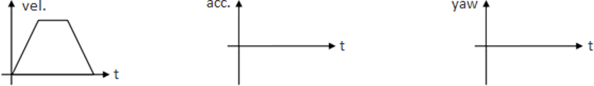

/2

**2.5** **By which six words of primitive motions can the shortest general path for a Dubins car be expressed? Furthermore, reach** 𝒒𝑮 **from** 𝒒𝑰 **by using one of these words, name it and draw your solution into the figure below. The crosses indicate center points of turning circles, indicating maximum curvature.**

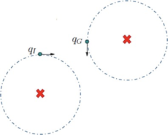

/4

**2.6** **With regards to heuristics, name an exemplary search algorithm using heuristics. Furthermore,**

**explain the “admissible condition” and the “monoton condition”.**

Exemplary algorithm:

Admissible condition:

Monoton condition:

/3

**2.7** **The two polygons A and B are checked for collision. Is the “Separating Axis Theorem” applicable for determining whether A and B collide? If not, give a short reason for your answer by describing how the theorem could be applied to the given obstacles and illustrate your answer in the figure.**

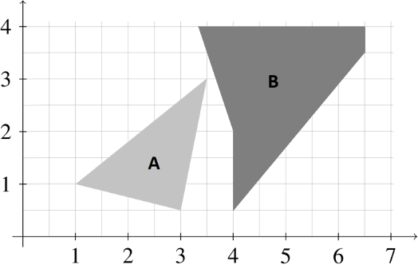

/4

# **Part 3: Data Fusion**

**3.1** **The transition of the position of the Kalman Filter state** 𝒙

= 𝒑𝒌] **to** 𝒙

= 𝒑𝒌+𝟏] **is**

𝒌 [𝒗𝒌

𝒌+𝟏

[𝒗𝒌+𝟏

**assumed as** 𝒑𝒌+𝟏 = 𝒑𝒌 + ∆𝒕 𝒗𝒌 **. Furthermore, assume a constant velocity transition from** 𝒗𝒌 **to**

𝒗𝒌+𝟏**. Please fill in the missing entries of the state transition matrix F of the given Kalman Filter**

**state prediction equation:**

𝑥𝑘+1 = [ ] 𝑥𝑘

/4

**3.2** **Please fill in the following missing functional names into the figure below according to Bowman Model.**

**{Hypothesis Generation, Predict, Associate, Update, Hypothesis Management, Detect}**

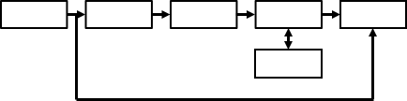

/3

**3.3** **Explain the concepts of the prediction, update and resampling steps of the Particle Filter.**

/3

**3.4** **Explain the main conceptual difference between the Extended and the Unscented Kalman Filter.**

/2

**3.5** **Given is a Gaussian-Mixture Birth Model for a PHD-Filter as**



**please state the names of the following entities/variables:**

𝑁:

| | 𝑤 : | | --- | |
| --- | --- |

(𝑖)

𝛾,𝑘

| | 𝑚 : | | --- | |
| --- | --- |

(𝑖)

𝛾,𝑘

| | 𝑃 : | | --- | |
| --- | --- |

(𝑖)

𝛾,𝑘

/4

# **Part 4: Neural Networks**

**4.1 Write under the three following neural network architectures the corresponding architecture name and give for each architecture an application example within the context of autonomous driving, explaining why this specific architecture is well suited for the chosen task.**

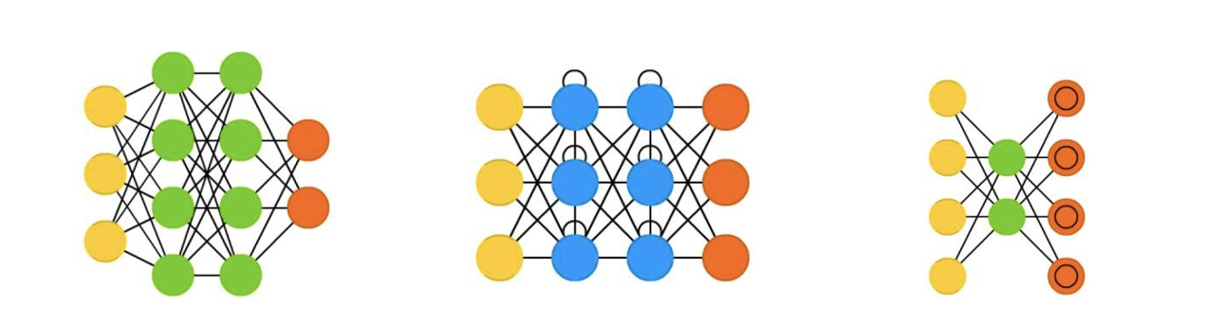

1: 2: 3:

Application Examples

1.

2.

3.

|  |  |  |  |  |  |
| --- | --- | --- | --- | --- | --- |
|  |  |  |  |  |  |
|  |  |  |  |
|  |  |  |  |  |

# **Part 5: Mapping**

**5.1** **Describe how the Pessimistic Fusion approach is defined for sensor grid maps and name one main disadvantage.**

/2

**5.2** **Explain the difference in how the local and global SLAM of the Cartographer work in terms of algorithms.**

/2

**5.3** **Explain the differences between an Occupancy Grid Map and a Reflection Grid Map.**

/2

# **Part 6: Car-to-X**

**6.1** **One vehicular service type is Mobile Broad Band (MBB). Name two other related main vehicular communication-service types (long version and their abbreviations) within the field of Car-to-X. Please describe for each of the three service types their targeted application purpose. Additionally, state for each of the three service types, how it relates to the difference between 4G communication standard and the 5G communication standard.**

1: Mobile Broad Band (MBB)

2:

3:

/5

**6.2** **One important technology which will be used within the 5G communication standard is Beam Forming. Please name three advantages which can be achieved with Beam Forming:**

/3

# **Part 7: Safety Analysis Methods for AV**

**7.1** **Assuming an existent control structure, what are the three main steps of the “System Theoretic Process Analysis”?**

/3

**7.2** **The “Safety of the Intended Functionality Process” consists of 8 main steps. The second step is the “Establishment of Validation Targets” and the fifth step is the “Functional Modification”. Explain these two steps and give an example for each of them.**

/4

# **Part 8: Ontologies**

**8.1 Explain the SWRL rule below in human language. Give an example for the situation and how the vehicle would react to the situation (you can draw a picture to describe the situation). How could the rule be extended to only allow the action, if the lead car is a truck?**

CrossableZone(?s), Car(?a), Car(?b), Lane(?l1), Lane(?l2), hasEmotion(?a, Nervous), isAfter(?a, ?b),

hasBesides(?l1, ?s), hasBesides(?l2, ?s), hasMotion(?b, Stopped), isOn(?a, ?l1), isOn(?b, ?l1), DifferentFrom(?l1, ?l2), isIlllegal(?l1, ?l2), isClear(?l2)

->

isNextOn(?a, ?l2)

/4

# **Part 9: AV architectures**

**9.1 Please fill in the missing main module category names of the robinos specification overview:**

|  |  |
| --- | --- |
|  |  |

/3

NOTES

## Autonomous Driving SS 2019 First name Last name

16/18

NOTES

17/18

DO NOT WRITE BELOW THIS LINE

|  |  |
| --- | --- |
|  |  |

18/18